# Download Media

1. Open your browser, and navigate to: <https://ubuntu.com/download/server>
2. Click on Download XX.XX.X LTS, XX.XX.X being the latest LTS version on this page.

1. Wait for the download to complete, most browsers will download this to c:\users\username$\Downloads. (username$ being the user you are logged into the system.)

# Create Virtual Machine

1. Launch **Oracle VM Virtual Box Manager**.
2. Click **Machine > New…**.

1. Click **Expert Mode**.

1. For Name, Type **DerbyNetServer**
2. For Folder, Select the location where you want to store the Virtual Machine Files.

**NOTE:** Recommend putting the virtual machine in its own folder, like the example image shows.

1. For ISO Image, Select the location where you downloaded the ISO File in, Download Media.
2. For Type, Select **Linux**
3. For Version, Select **Ubuntu (64-bit)**.
4. Check, **Skip Unattended Installation**.

1. Expand **Hardware**.
2. For Base Memory, type **4096**.
3. For Processor, select half the number of processors the system has.

1. Expand **Hard Disk**
2. For Hard Disk File Location and Size, leave the location as is, set the size to **127.00GB**.
3. Click **Finish**.

1. If the virtual machine starts automatically, Right click the machine name.
2. Hover over **Stop >** Click **Power Off**.

1. Right click the machine name **>** Select **Settings**.

1. Click **Network**.
2. For Attached To, select **Bridge Adaopter**.
3. For Name, select the physical network card for the system.

**NOTE:** Each system will be different because the network adapter will be called something different for each system.

1. Select **Storage >** Select **Controller: SATA**.
2. Click the Second icon.

1. Click **Create**.

1. Click **Expert Mode**.

1. For Size, Type **80.00GB**.
2. Click **Finish**.

1. Select **DerbyNetServer_1.vdi**.
2. Click **Choose**.

1. Click **OK**.

1. Right click **DerbyNetServer**.
2. Hover over **Start >** Click **Normal Start**.

# Installation of Operating System

1. Press **Enter** on Try or Install Ubuntu Server.

1. On the *Welcome* screen, press **Enter**.

1. On the *Installer update available*, Press **Enter**.

**NOTE:** If not already selected, you can press Tab to get Update to the new installer highlighted as green. Sometimes this may not come up and you can skip to the next step.

1. On the *Keyboard configuration*, press tab until **Done** is highlighted. Press **Enter**.

1. On the *Choose type of install*, leave the defaults selected, press tab until **Done** is highlighted. Press **Enter**.

1. On the *Network connection*, press Tab until **Done** is highlighted. Press **Enter**.

1. On the *Configure proxy*, press Tab until **Done** is highlighted. Press **Enter**.

1. On *Configure Ubuntu archive mirror*, wait for the list to populate. Press Tab until **Done** is highlighted. Press **Enter**.

1. On *Guided storage configuration*, . Press Tab until **Done** is highlighted. Press **Enter**.

1. On the *Storage configuration*, Press Tab until the selected is on free space 79.998G
2. Press **Enter**.

1. Press Tab until **Add GPT Partition** is highlighted.

1. Press Tab until Mount is highlighted.
2. Press **Enter**.
3. Select **Other**.
4. Type **data**.
5. Press Tab so that **Create** is highlighted green.
6. Press **Enter**.

1. Pressing Tab will highlight all the hard drives make sure **“local disk” 80.000G** has a **partition 1** as shown below and press Tab until **Done** is highlighted green. Press **Enter**.A screenshot of a computer

   Description automatically generated
2. On the Confirm destructive action Press Tab until **Continue** is Red and press **Enter**.

1. On the Profile Setup:
   1. For Your name, type **pack442**.
   2. For Your server name, type **derbynetsrv01**.
   3. For Pick a username, type **pack442**.
   4. For Choose a password, type **pack442**.
   5. For Confirm your password, type **pack442**.
   6. Press Tab so **Done** is highlighted green, press **Enter**.

1. On the *Upgrade to Ubuntu Pro*, keep Skip for now selected with a X. Press **Enter** to Continue.

1. Press the **spacebar**, so that Install OpenSSH Server is selected.
2. Press Tab until **Done** is highlighted green, press **Enter**.

1. On *Featured Server Snaps*, Press Tab until **Done** is highlighted green, press **Enter**.

1. On the *Install Complete!,* wait until the option **Reboot Now**, is showing and then press Tab until it is highlighted as green, then press **Enter**.

**NOTE**: If you receive a Failed unmount /cdrom, just Press Enter on this screen. The system will reboot.

1. Login to the server, with the username you used in Step 21 and press **Enter**.

1. Type the password with the password you used in Step 21 and press **Enter**.

1. Type **sudo apt update** and press **Enter**.

**NOTE:** You may be prompted for the password for pack442, type that password as you used in Step 21 and press **Enter**.

1. Type **sudo apt upgrade** and press **Enter**.

**NOTE:** You may be prompted for the password for pack442, type that password as you used in Step 21 and press **Enter**.

1. Wait for the upgrade or packages to complete.

1. Press Tab until **OK** is selected and press **Enter**.

1. Type **sudo apt-get install virtualbox-guest-additions-iso** and press **Enter**.

1. You may be prompted for the password for pack442, type that password as you used in Step 21 and press **Enter**.

1. Press **Y** and Press **Enter**.

1. Press Tab until **OK** is highlighted and press **Enter**.

1. Type sudo init 6 and press Enter.



**NOTE:** This completes the Installation of Operating System, Continue to the next step: Post Configuration.

# Post Configuration

Before completing these steps, make sure Putty is installed following these instructions.

1. Login to the virtual machine via Virtual Box Manager.
2. Look for the IPv4 address for enp0s3.
3. Note this address down.

1. Launch Putty

1. Type the **ip address** you retrieved in Step 3.
2. Click **Open**.

1. Click **Accept**.

1. On the login as type, **pack442** and press **Enter**.

**NOTE:** This would be the username you provided in Installation of Operating System, Step 21.

1. On [pack442@XXX.XXX.X.XXX](mailto:pack442@XXX.XXX.X.XXX) password, type **pack442** and press **Enter**.

**NOTE:** This would be the username you provided in Installation of Operating System, Step 21.

1. Type **sudo apt update** and press **Enter**.

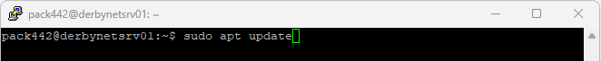

1. If prompted, type the password for pack442 and press Enter.

**NOTE:** This would be the username you provided in Installation of Operating System, Step 21.

1. Type **sudo apt-get upgrade** and press **Enter**.

1. Press **Y** and Press **Enter**.

1. Press Tab until **OK** is highlighted, Press **Enter**.

1. Type **sudo init 6** and press **Enter**.

1. Continue to Installation of Derbynet Software.

# Installation of Derbynet Software

<https://www.derbynet.org/builds/>

1. Launch **Putty**

1. Type the **ip address** you retrieved in Step 3.
2. Click **Open**.

1. Click **Accept**.

1. On the login as type, **pack442** and password and press **Enter**.

**NOTE:** This would be the username you provided in Installation of Operating System, Step 21.

1. Type **sudo apt-get update** and press **Enter**
2. Type **sudo apt-get install -y apt-transport-https** and press **Enter**

**NOTE:** You will be prompted for the password for pack442, which was set during install.

1. Once completed, continue to the next step.

1. Copy and past the following into putty and press **Enter**.

*sudo apt-get update*

*sudo apt-get install -y apt-transport-https*

*wget -q -O- https://derbynet.org/debian/derbynet.gpg | *

*sudo tee /usr/share/keyrings/derbynet-archive-keyring.gpg > /dev/null*

*echo "deb [arch=all signed-by=/usr/share/keyrings/derbynet-archive-keyring.gpg] " *

*" https://derbynet.org/debian stable main" | *

*sudo tee /etc/apt/sources.list.d/derbynet.list > /dev/null*

*

1. Type **sudo apt-get install derbynet-server** and press **Enter**.

1. Press **Y** and then **Enter**.

1. Once completed you will receive a window similar to this:

# Post Configuration Derbynet Software

Download the configuration files needed at: <https://github.com/majora15/Pack442PineWoodDerby-main-main/archive/refs/heads/main.zip>

## Extract Configuration Files

1. Navigate to where you download the PineWoodDerbySetup-main.zip file to.
2. Right click > Click **Extract All**.

1. Click **Extract**.

1. Continue to Certificate Update

## Certificate Update

This step required WINSCP to be installed, for Instructions on installing this please go to Install WinSCP.

**(See document “Creating SSL Certificate”)**

1. Type **WinSCP** **>** Click **WinSCP**.

1. Type the ip address of the virtual machine.
2. Type the following:

Username: pack442

Password: pack442

1. Click **Login**.

1. Click **Yes / Accept**.

1. Navigate to the location of the configuration files that you extracted in **Extract Configuration File, Step 3**.
2. Click on etc.

1. Drag the ssl folder over to /home/pack442.

1. Launch Putty and SSH to the server.

**NOTE:** You may already have this open.

1. Type **sudo** **cp ssl/certs/pack442-coughlinfam-com.pem /etc/ssl/certs/pack442-coughlinfam-com.pem** and press **Enter**.

**NOTE:** You may be prompted for the pack442 password.

1. Type **sudo cp ssl/private/pack442.coughlinfam.com.key /etc/ssl/private/pack442.coughlinfam.com.key** and press **Enter**.

1. Type **sudo su** and press **Enter**.
2. Type **cd /etc/ssl/private/** and press **Enter**.
3. Type **chown root:ssl-cert pack442.coughlinfam.com.key** and press **Enter**.
4. Type **chmod 640 pack442.coughlinfam.com.key** and press **Enter**.

1. Type: **cd /etc/nginx/sites-available** and press **Enter**.
2. Type: **vi default** and press **Enter**.

1. Press INS button on keyboard.
2. Change these lines in red.

*# SSL configuration*

*#include snippets/snakeoil.conf;*

*ssl_certificate /etc/ssl/certs/pack442-coughlinfam-com.pem;*

*ssl_certificate_key /etc/ssl/private/pack442.coughlinfam.com.key;*

1. Press **ESC**
2. Type**:wq!** (including “:”) and press Enter.

1. Type: **exit** and press **Enter**.
2. Type: **sudo /etc/init.d/nginx restart** and press **Enter**.
3. Type: **systemctl status nginx.service** and press **Enter**.

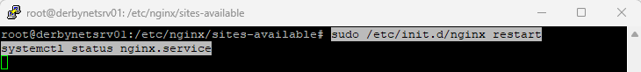

1. Press **q**.
2. Keep the ssh session open and go to Setup /data for Replay, Car Pictures, and Racers.

## Copy config-url

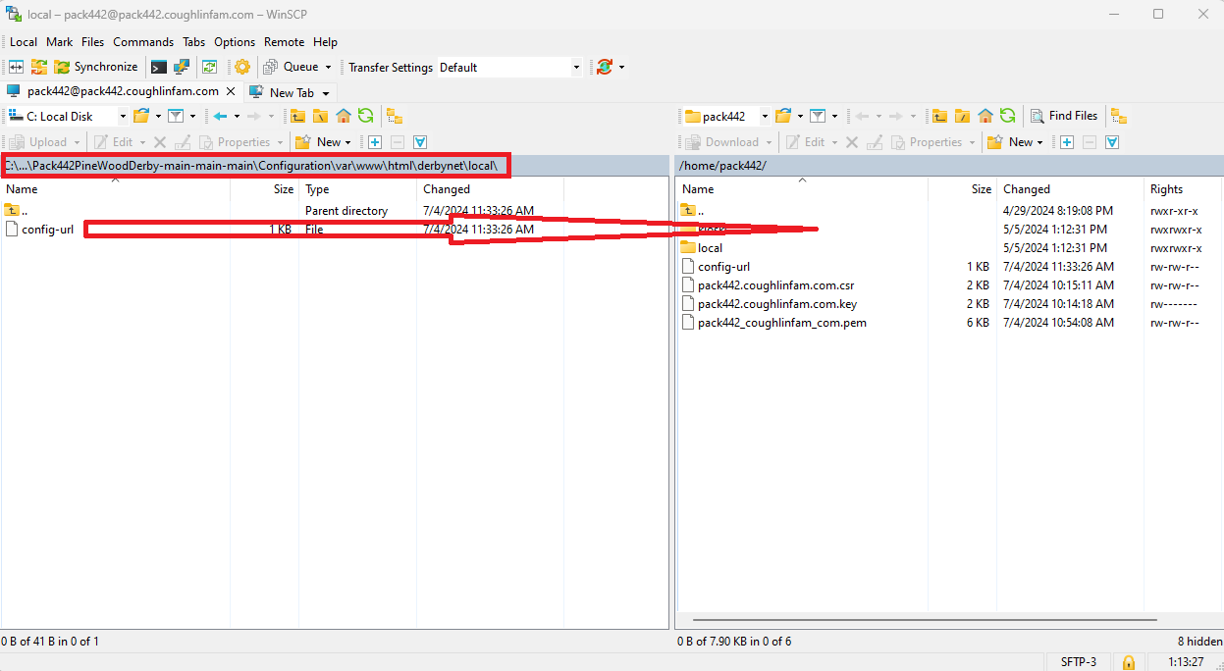

## Setup /data for Replay, Car Pictures, and Racers

1. Copy and past the following into the putty session and press **Enter**.

*cd /data*

*sudo mkdir derbynet*

*sudo chown www-data:www-data derbynet/*

*sudo chown 777 derbynet/*

*cd derbynet*

*sudo mkdir pack442*

*sudo chmod 777 pack442/*

*sudo chown www-data:www-data pack442/*

*cd pack442/*

*sudo mkdir cars*

*sudo mkdir racers*

*sudo mkdir replays*

*sudo chown www-data:www-data cars/*

*sudo chown www-data:www-data racers/*

*sudo chown www-data:www-data replays/*

*sudo chmod 777 cars*

*sudo chmod 777 replays/*

*sudo chmod 777 racers/*

1. Continue to Custom Kiosk Pages.

## Custom Kiosk Pages

1. Type **WinSCP** **>** Click **WinSCP**.

1. Type the ip address of the virtual machine.
2. Type the following:

Username: pack442

Password: pack442

1. Click **Login**.

1. Click **Yes / Accept**.

1. Navigate to the location of the configuration files that you extracted in **Extract Configuration File, Step 3**.
2. Click on **var** > click on **www** >click on **html >** click on **derbynet**.

1. Drag the ssl folder over to /home/pack442.

1. Type: **sudo cp kiosks/pack442-* /var/www/html/derbynet/kiosks/** and press **Enter**.

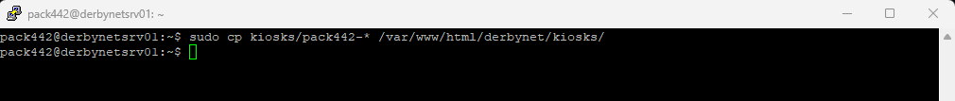

1. Type: **sudo cp local/config-url /var/www/html/derbynet/local/** and press **Enter**.



1. Type exit and press Enter.

1. Post Configuration of the software is done.

# Appendix:

## Installation of Putty

1. Navigate to: <https://www.chiark.greenend.org.uk/~sgtatham/putty/latest.html>
2. Download the version that best fits your machine (most modern machines will select 64-bit x86).

1. Click on the download, to install.

1. Click **Next**.

1. Click **Next**.

1. Click **Install**

1. Click **Yes** if you receive this message box.

1. Click **Finish**.

1. Installation of putty is complete; continue to the step you were on.

## Install Winscp

1. Navigate your browser to: <https://winscp.net/eng/download.php>.
2. Click **Download**.

1. Click on the download, to install.

1. Click **Install for all users (recommended**).

1. Click Yes if you receive this message.

1. Click **Accept**.

1. Click **Next**.

1. Click **Next**.

1. Click **Install.**

1. Uncheck the two boxes and click **Finish**.

1. Installation of Winscp is complete, continue to the step you were on.